You can learn more about what **StrongerThruCancer** has to offer at strongerthrucancer.com

**StrongerThruCancer** is a virtual community to build and support your physical and mental wellness on your journey through cancer. Whether you are actively fighting cancer or recovering, beating cancer begins with self-care.

**StrongerThruCancer** includes classes for the Body, Mind, and Heart – both live and recorded.

Classes for the Body include: Strength, Resistance, Yoga

Classes for the Mind and Heart include: Meditation, Journaling, Mindfulness Activities, Group Share/Support

Over 10 live classes per week, plus many that you can access whenever convenient for you.

A 6 month subscription to Stronger Thru Cancer uses 3 squares on your Passport.

To initiate your 6 month membership, please have your doctor’s office sign the attached physician referral form and contact Priscilla at [strongerthrucancer@gmail.com](mailto:strongerthrucancer@gmail.com)

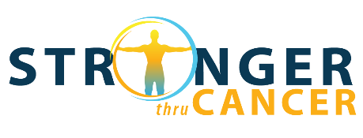

**UFH/Stronger Thru Cancer Physician Referral Authorization**

Patient is cleared for unsupervised exercise. (Please check box if accurate.)

Precautions/limitations/special conditions that the patient should be aware of with the understanding that when taking a virtual exercise program, it is primarily the patient’s obligation to adhere to these special precautions:

___________________________________________________________________

_________________________________________________________________________________________________________________________________________________________________________________________________________

**Patient Information:**

Name:_______________________________________________________

Phone: ______________________________________________________

Date of Birth: ___________/___________/____________

Patient Signature Acknowledging Precautions / Limitations/ Conditions (if any):

____________________________________________________________

**Physician/Medical Provider Information:**

Name (print): _______________________________________________________

Signature: __________________________________________________________

Date: __________________________________________

Phone: _________________________________________

**Offer includes 6-month individual virtual membership with Stronger Thru Cancer**

• To activate your membership, please email Priscilla at [strongerthrucancer@gmail.com](mailto:strongerthrucancer@gmail.com), note that you are a Unite for HER participant and include this signed form